
PORTAGE LAKES KIWANIS
COMMUNICATOR
May 11, 2025

FOOD PANTRY DEDICATION
Wednesday's Child, a dedicated 501(c)(3) organization serving the communities surrounding New Franklin, Ohio is thrilled to announce the launch of its third food pantry located at the Portage Lakes Kiwanis Civic Center, 725 Portage Lakes Drive, in Coventry Township. This new location aims to replicate the success of the pantries in Norton and New Franklin. The new pantry offers discreet, accessible food assistance for Coventry Township families in need. The new Coventry Township food pantry is a testament to the power of community collaboration. Wednesday's Child gratefully acknowledges the Portage Lakes Kiwanis, whose instrumental support made this project a reality. The pantry was skillfully built by Kiwanis members Jon Vielhaber and Al Grzeschik, with additional material donations from fellow Kiwanis member Steve Hess. Kathy Chiodo graciously assisted with the painting of the finished pantry. Local businesses JTC Contractors LTD of Green and Graphic Accents of Green also contributed to the project. Notably, much of the pantry unit was crafted from leftover and reclaimed materials, highlighting a commitment to resourcefulness. The initial stocking of the pantry was generously provided by Kiwanis member Jon Vielhaber. For years, Wednesday's Child has been a vital resource, providing clothing, hygiene products, and household essentials to children and adults with disabilities through close collaboration with local school districts and area agencies, including a valued partnership with Summit DD. The establishment of food pantries is a natural extension of their commitment to meeting the community's basic needs. Recognizing that individuals in need may be hesitant to ask for help directly, Wednesday's Child offers pantries that provide a dignified, low-barrier way to receive support, while also giving the broader community an opportunity to help their neighbors. Stocked with non-perishable food and hygiene items, these easily accessible pantries serve as a crucial resource for those facing food insecurity. Thanks to the consistent generosity of dedicated donors, they remain well-stocked and ready to serve. The entire team at Wednesday's Child extends their sincere gratitude to the Portage Lakes Kiwanis and all the individuals and businesses who contributed their time, skills, and resources to bring this new food pantry to fruition. This expansion into Coventry Township underscores Wednesday's Child's ongoing commitment to serving the surrounding communities and making a tangible difference in the lives of those they support. The dedication was held at the Kiwanis Civic Center on Wednesday April 30th.

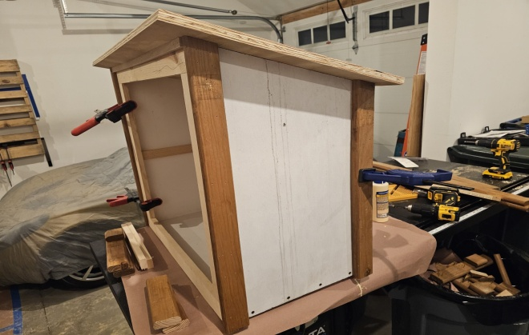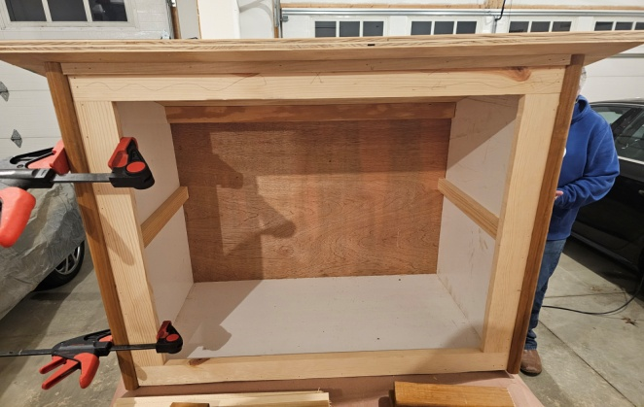

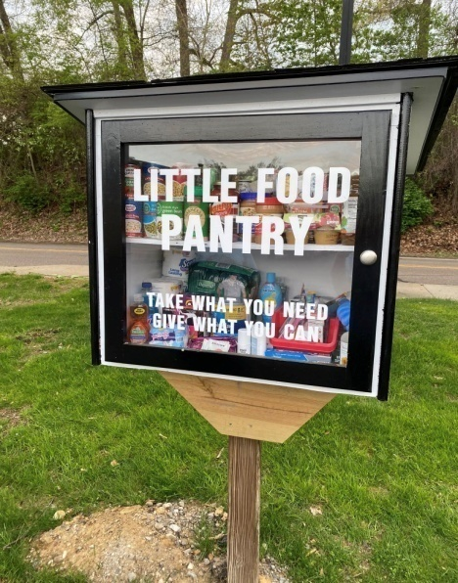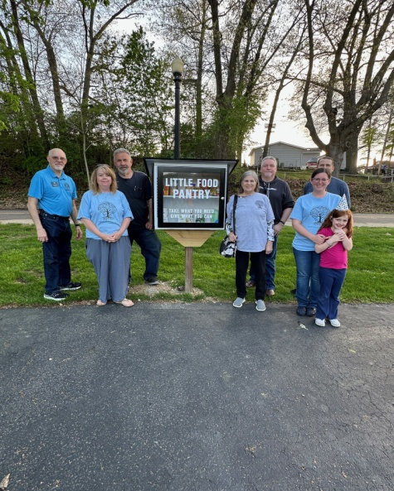


We will again have a Kiwanis float in the New Franklin Memorial Day parade. The date will be Monday May 26th. The parade route runs from Grace Bible Church on Manchester Road to the Manchester Cemetery on Nimisila Road. If you have any ideas on how to decorate the float or would like to volunteer to help out that day, please see Steve Hess who is the chair of this event. SAVE THE DATE, WE NEED YOUR HELP!

SCOTT SHOOKMAN MEMORIAL SCHOLARSHIP
Every year our club offers four $1,500 scholarships; two for Manchester seniors and two for Coventry seniors. The recipients are chosen based on academics, extra-curricular activities, community service, service to their home school, and financial need. All of the applicants are highly qualified so it is always a tough decision to choose just two winners from each school. President Dietz will present the scholarships at the Senior Awards night at both schools and at that time the recipients will be revealed. Our annual Scholarship Banquet will be held at the Civic Center on Wednesday, May 28th. Please make plans to attend this dinner to support the scholarship program, the scholarship recipients, and the Shookman family. The scholarship committee consists of: Sam Reynolds, chair, Becky Shookman, Gene Cole, and Cathy Dietz.
ALSO ANY ONE WANTING TO EAT DINNER WILL NEED TO MAKE A RESERVATION NO LATER THAN MAY 22ND BY EMAIL TO al@plkiwanis.org. THE COST OF THE DINNER IS $15.00

CLUB ELECTIONS
Club elections will be held on Wednesday, May 14th this year. We are specifically in need of a Vice President. If you or someone you know would be interested in this position or if you would like more information, please contact Al Grzeschik. We will be voting for a slate of Officers & Board of Directors for the 2025-2026 year. Please attend this meeting to have your voice heard and your vote count!

Bottom of Form
Top of Form
Bottom of Form
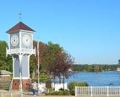
The Coventry Parks Advisory Committee will host 'Food Truck Mondays' one Monday each month this summer at the Coventry Clock Tower. There will be great food and fun on June 9th, July 14th, and August 11th from 5 to 8pm. There will be tables set up to sit down and eat. Our club will set up an 'information' table on these three dates to let the Portage Lakes community know what our club is up to. Save these dates if you will be able to come down and help out. More details to follow.

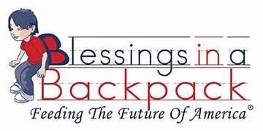
Please continue to bring in food for our Blessings in a Backpack program. We collect non perishable food items for our local school districts to help children that rely on school breakfast and lunches. The food will be sent home with kids over weekends and holiday breaks to make sure they have something to eat; many families are struggling. Some suggestions would be single serving macaroni and cheese, fruit cups, crackers, peanut butter, or any food item with an easy pop top. When you are out shopping please consider adding a few items to your cart and dropping them off at the Civic Center. There are receptacles outside the Civic Center so you can drop your donation off any time or you can bring them in any Wednesday from 6:00 to 8:00 pm.

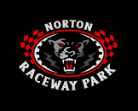
FUNDRAISING OPPORTUNITY
Our club has been offered the chance to sell 50/50 raffle tickets to the racing fans at the Norton Raceway Park (formerly Barberton Speedway) on Saturday, May 31st. Thanks to the members that have volunteered to sell the tickets, we could still use a few more! We will retain half of the money collected with the other half going to the ticket winner. We will hope for perfect weather and a big crowd that night. Raffle ticket sellers will not be required to pay for admittance.



The 'Clean up Portage Lakes Drive' event was held on April 23rd. Many thanks to all of the teams that went out and cleaned up Portage Lakes Drive from the Clock Tower to Manchester Road and pick up all the trash they could. Afterwards we had a hot dog and mac-n-cheese dinner thanks to Al and Bob.

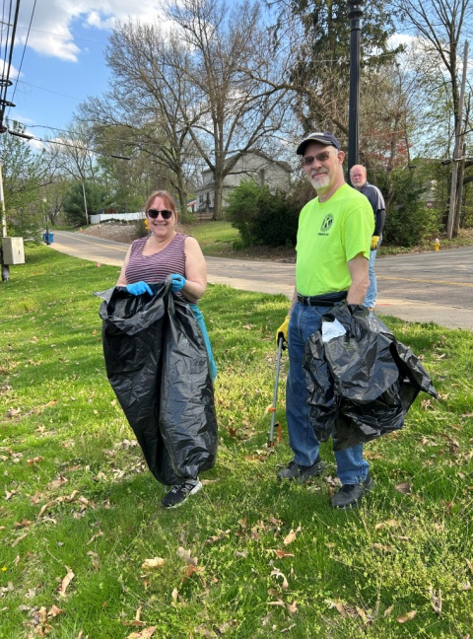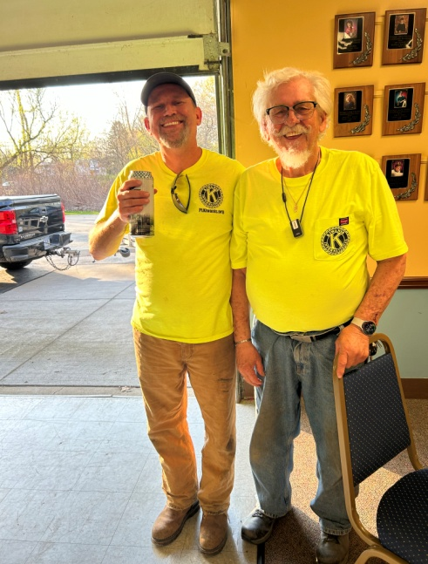


OHIO STATE FOOTBALL TICKET RAFFLE
Our club will again participate in the Buckeye Ticket Raffle fundraiser. We will sell raffle tickets for $5.00 each, our club will keep $3.00 for every ticket sold and the other $2.00 will be sent back to the Columbus Kiwanis Foundation. The winner will receive 2 tickets to all seven OSU home football games. The seats are in Section 22C, Row 26 which is around the 45 yard-line. Steve Hess will be our Club Chair for this fundraiser. The drawing for the winner will be held on Monday, August 18, 2025. This is a simple way to earn a few extra dollars for our club. Last year our own Stanley Vaughan sold the winning ticket! Tickets will be available at our next meeting on May 14th, please see Steve to get yours to sell.



The Nolley Elementary School 'FUN FAIR' will be held on Friday, May 30th from 5:00 pm to 8:00 pm. The event offers carnival games, food, and fun for the community. The PTA has asked our club for assistance. If you are available to volunteer that night please let Al Grzeschik or Kelley Nagy know. Volunteers will need to arrive at Nolley School by 4:45 pm. You can work an hour or the entire event!

Nolley has an online sign up so we know who to expect, please copy this link to sign up: https://www.signupgenius.com/go/10C0D4BABA92EA6FE3-56701224-funfairs
The night of the event you will just need to come to the volunteer table in the front lobby to check in and then we can get them to their volunteer station.


Our 3rd PLK Kentucky Derby was held on May 7th at the Civic Center, complete with horses, jockeys, and betting.
Horse#1, The Professor, jockey Rosanne Edwardson, supporting our Scholarship Program
Horse#2, Rudolf the Red Nosed Horse, jockey Steve Hess, supporting Santa Delivery
Horse#3, Shiver me Timbers, jockey Bob Fowler, supporting Pirate Day
Horse#4, Petal Power, jockey Stan Vaughan, supporting Rose Day
Horse#5, Maple Stirrip, jockey Judy Thompson, supporting Pancake Breakfast
Horse#6, Eggcellence, jockey Chuck Seeley, supporting Easter Egg Hunt

Horses #1 and #2 were neck and neck all the way around the track, but in the end it was Horse #5 that came on strong in the end and won the Derby! Five people picked Horse #5 for the win and each won a small prize. Thank you to all that participated, it was a fun event.

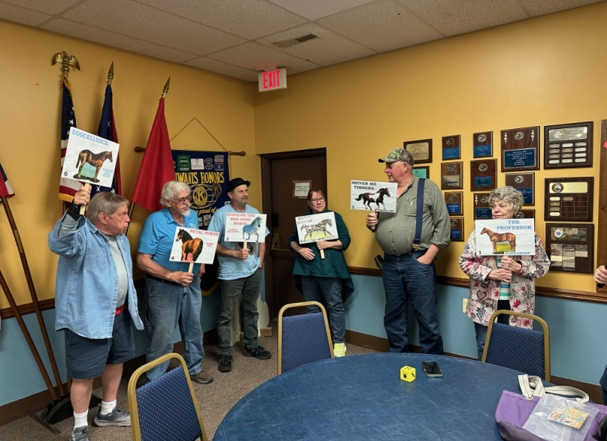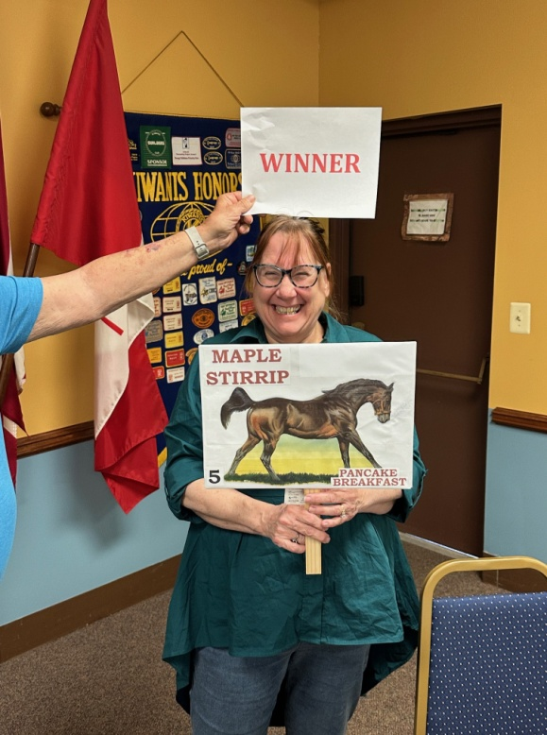

Community Events coming up:

The Portage Lakes Purple Martin Association will again hold their Education Days for Coventry and Manchester Middle School students. May 21st will be Manchester and May 22nd will be Coventry. If you are able to help, please contact Kay Lukac at kaylukac@yahoo.com, the Purple Martin Association is always looking for good helpers.

Friday, May 30th will be the Nolley Elementary School Fun Fair. This is a fun event for children, students, and families in New Franklin. Our club will be helping out with kitchen duty and serving food. Save the date if you can volunteer that night.

The Portage Lakes Purple Martin Association will hold their annual Martinfest on Sunday, June 29th at the State Mill Boat ramp. Please let Kay know if you will be able to help.

The Portage Lakes Fireworks Association will hold their annual fireworks celebration on Saturday July 5, 2025 with a magical display over the Portage Lakes.

The Dragon Dream Team will hold their annual Dragon's on the Lake Boat Festival at the Portage Lakes State Park on Saturday July 19th. This is an all day event that more than 1,500 people will attend and will be a day of community, camaraderie, and competition. Our club will help out transporting people from the parking area down to the beach area.



BIRTHDAYS:
05/01 Sam Reynolds
05/17 Chuck Seeley
05/31 Tom Burge

CLUB ANNIVERSARIES:
Jim Davis - 34 years
Al Grzeschik - 29 years
Paul Schuckert - 23 years
Dale Dietz - 14 years
Dana Roderick - 14 years
Kevin Powell - 3 years
Carol Derry - 2 years

WEDDING ANNIVERSARIES:
05/23 Melissa & Tim Millmier

KIWANIS FAMILY NEWS: Please keep our members and friends in special
thought and prayer.
Judy Hunter

UPCOMING MEETINGS / CALENDAR OF EVENTS:
>May 19, Division Meeting at Westfield Center
>May 26, New Franklin Memorial Day Parade
>May 28, Scholarship Banquet at Civic Center
>May 30, Nolley School Fun Fair, 5:00 to 8:00pm
>May 31, Norton Raceway Park 50/50 fundraiser

A LITTLE FURTHER DOWN THE ROAD:
>June 4, Regular Meeting & Board Meeting
>June 9, First Food Truck Frenzy at Clocktower
>June 25, Regular Meeting & Board Meeting
>June 29, Martinfest, State Mill Boat ramp
>July 5, Portage Lakes Fireworks
>July 12, Pancake Breakfast at Civic Center
>July 14, Second Food Truck Frenzy at Clocktower
>July 19, Dragons on the Lake Festival
>July 26, Pirate Day on the Lake, Portage Lakes State Park
>August 11, Third Food Truck Frenzy at Clocktower

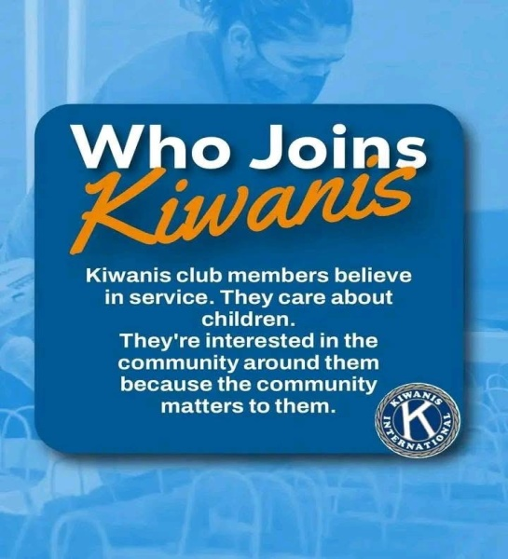

Kiwanis International Convention. The annual convention will take place in Pittsburg Pennsylvania June 25th thru June 28th. There will be seminars to choose from including; Building Club Membership, service projects for your community, fundraising ideas, and much more. There will be guidance in becoming a skilled Kiwanis leader, and you will be able to connect with fellow Kiwanians from all over the world for this exciting event. One of the Key Note speakers will be Henry Winkler, AKA 'The Fonz'. If you have never attended an International Convention now is your chance since it is being held just two hours away in Pittsburg. If you need more information or would like to register please see Secretary Cathy.

Ohio District Convention. This convention will be held in Warren, Ohio August 1st thru August 3rd, 2025. This will be a time for Kiwanis members to come together in fellowship, education, and to handle the business of the District which included electing leadership and voting on other matters. If you would need more information or would like to register please see Secretary Cathy.

ALL ABOUT PLK…Our club is currently meeting every Wednesday. You can join us at 6:30 pm for dinner, which is catered by Lukity’s Restaurant, a full meal for just $15.00, or you can attend any meeting which begins at 7:00 pm. We’d love to have you.

We meet at the Civic Center, located at 725 Portage Lakes Drive, Akron, OH 44319.
Telephone number (330) 644-8967.

Our website is: plkiwanis.org and please check out and like our Face book page,
under Portage Lakes Kiwanis.

KIWANIS MISSION STATEMENT - Kiwanis is a global organization of volunteers dedicated to improving the world one child and one community at a time.

Published on the first and third week of the month, Cathy Dietz, Editor.

